WORKBOOK_TEMPLATE user guide
For this program to work, the directory should contain an img folder with a logo.ico file, a configuration file titled config.ini, an optional lot.csv and the executable WORKBOOK_TEMPLATE.EXE file itself. Launching the application displays the graphical user interface below:
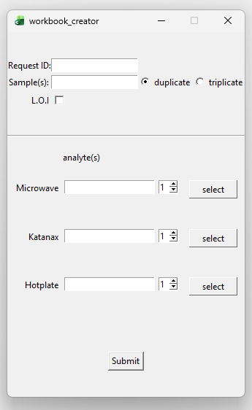
Figure 1: graphical user interface.
You are presented with an interface to input the request id, samples, and a check box to apply a L.O.I correction for the analysis and a set of radio buttons to set the samples as duplicate or triplicate. After filling out the information about the request, you then input the metals analyzed and their respective digestion method. I’ve attached a sample request report to walk through building a workbook.
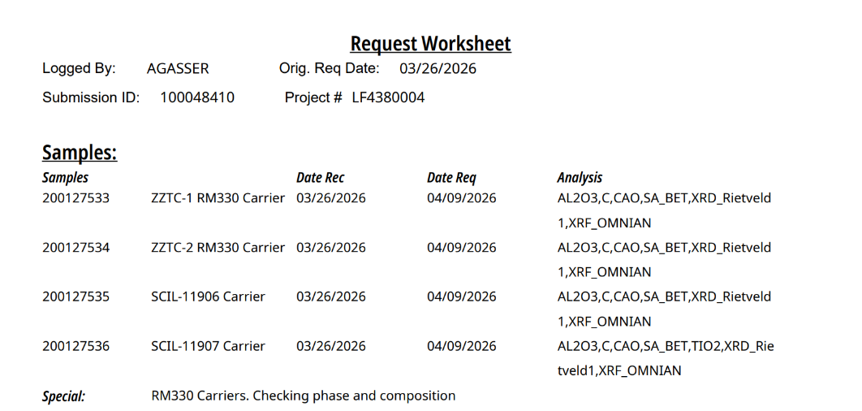
Figure 2: sample request worksheet.
Note that this sample request contains Al2O3, CaO for all 4 samples, but only sample 200127536 contains TiO2. To build this sheet, a separate digestion needs to be created to capture TiO2. Samples can be inputted as a comma or white space separated list; I’ve also included a shortcut if all the samples in the analysis are sequential. shortcut=leading_sample_id(n), so in our case: 200127533(4) = 200127533, 200127534, 200127535, 200127536.
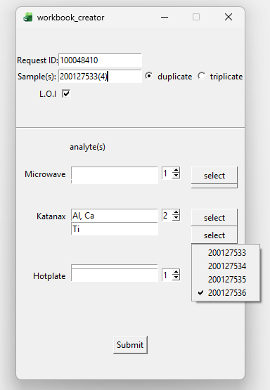
Figure 3: Selecting Ti analysis for sample 200127536.
Note the separate Ti Katanax digestion to capture Ti for sample 200127536; all the other samples are preselected for the Al, Ca Katanax digestion. Once all the pertinent info is put into the application, click on the submit button to create master_woorkbook.xlsx. You are then presented with a workbook with a digestion page and a tab for each of the samples.
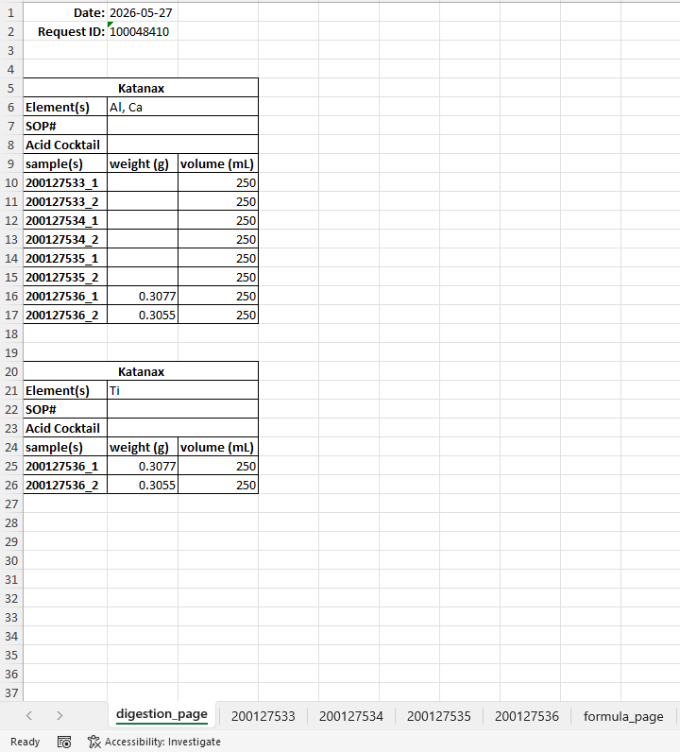
Figure 4: digestion page.
Note that the 200127536 duplicates from each digestion contain the same sample weight since they are the same solution but separated to capture the Ti analysis that is not present from the other samples.
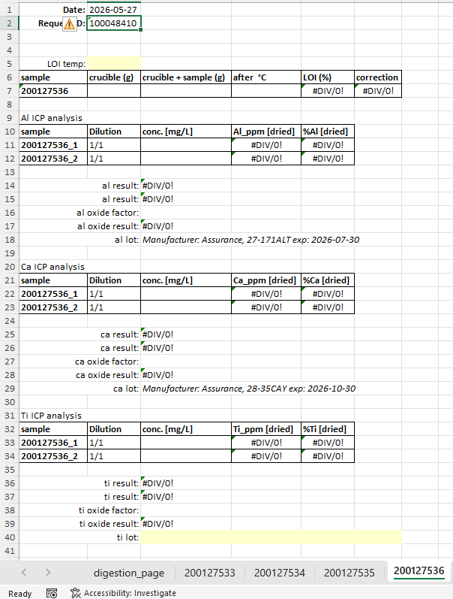
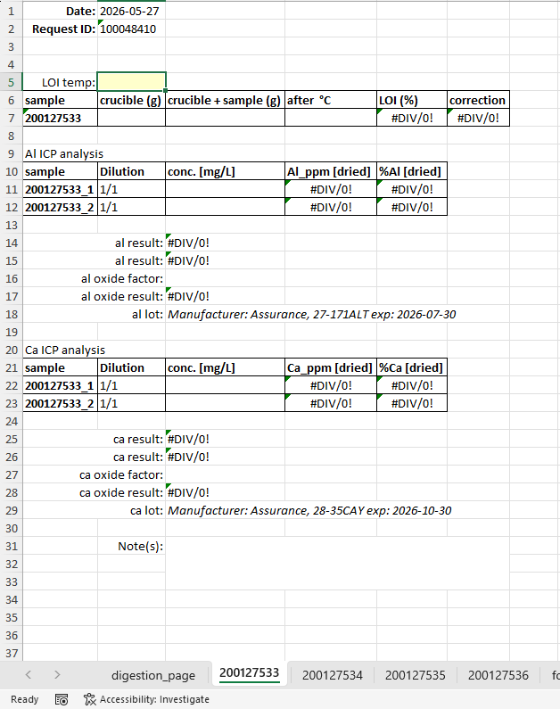

Figure 5: sample 200127533 displaying Al and Ca analysis.
Figure 6: sample 200127536 displaying Al, Ca and Ti analysis.
The software will extract the correct lot data from the lot.csv file if the lot exists and is not expired. Note the yellow unfilled ti lot box implies that either the lot.csv does not contain a ti entry or that is expired.
Analysis types:
Opening the configuration file, you can control the analytes that require titration analysis or any other analysis type.
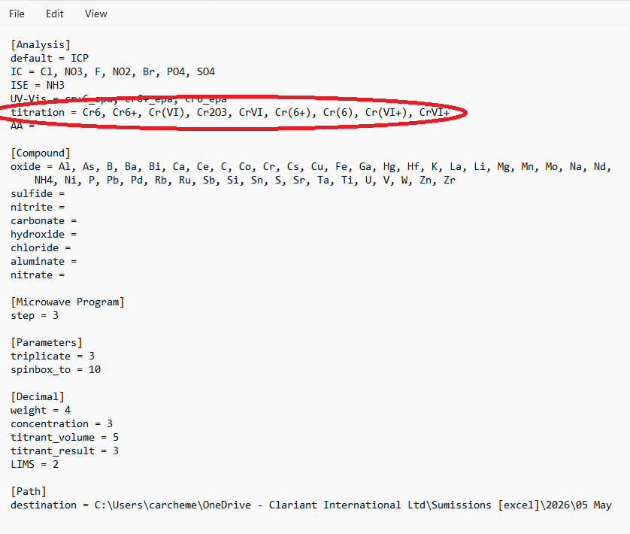
Figure 7: Analytes tied to titration analysis.
Cr(III) analyst is a special type of titration analysis that takes the difference between Cr2O3 and Cr(VI) titration analysis. Let’s walk through how to set that up in the program.
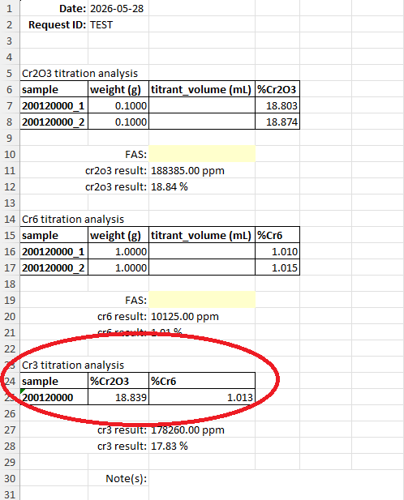
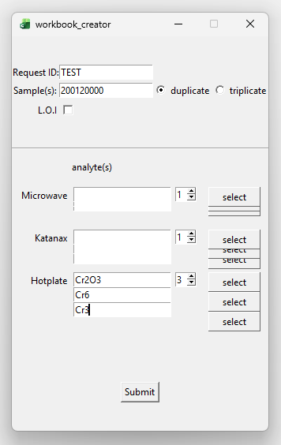
Figure 9: Cr(III) analysis.
Figure 8: Cr(III) titration analysis setup.
Any analytes that are not define in the Anlysis section defaults to ICP analysis. Note that this section of the configuration is dynamic meaning that if an instrument were to be instroduced in the lab we can capture this in our analysis. For example we can add HPLC anlysis for Cs.
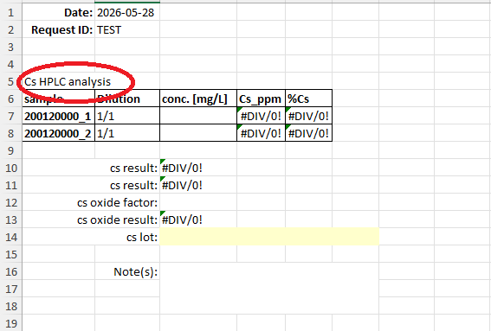
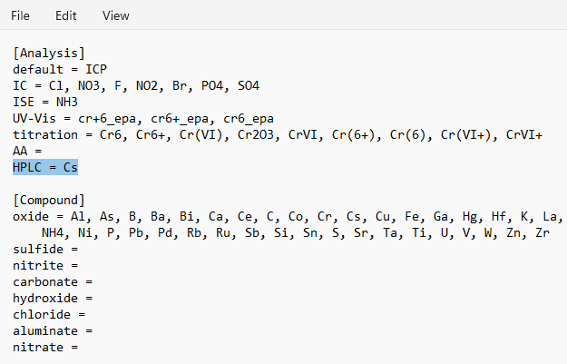
Figure 11: Cs HPLC analysis.
Figure 10: configuring HPLC analysis for Cs.

We can also control the chemical compound of an analyte, for example instead of reporting Na oxide we can report Na sulfite by creating a sulfite list in the configuration file and adding Na.
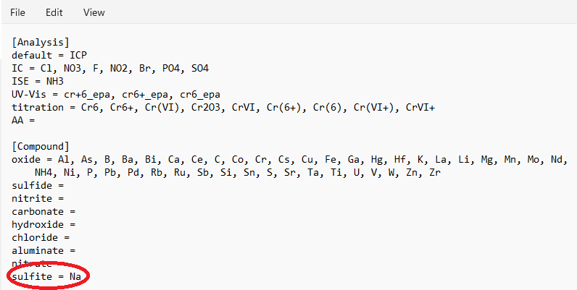
Figure 12: Creating a new metal compound for analysis.
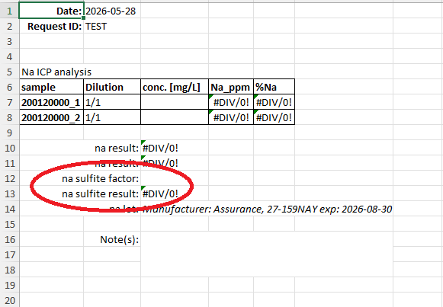
Figure 13: New Na sulfite factor and result.
Location of the saved master_woorkbook.xlsx is controlled by attaching a URL to directory in the Path section of the configuration file. If a path is not provided, it defaults to directory that the program is running. Use <F1> as shortcut to open the config.ini configuration file. The lot.csv file is maintained as a csv file that can be open with a text editor or excel. Expiration dates should be formatted as such: Month date yyyy, month can be full form or abbreviated.
Shortcuts
Instead of typing the elements into the digestion field, double-clicking the field opens a periodic table for elements selection.
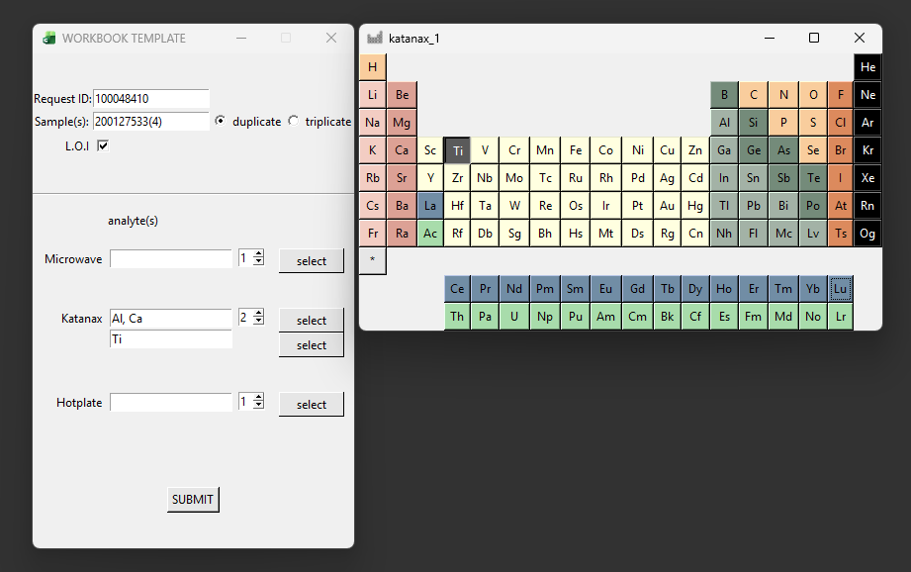
Figure 14: Periodic table window.
Other Shortcuts
Double-clicking in the Request ID autofill 1000 as an entry and double-clicking in the Sample(s) autofill 20012 as an entry, both autofill values can be configured in the config.ini configuration file.
<Control-l> or <Alt-l> to open lot.csv file.
<Control-comma> or <Alt-c> to open config.ini configuration file.

